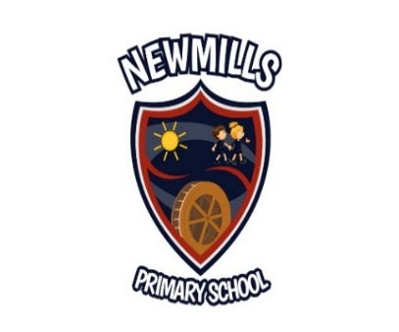

17th June 2020
Dear Parent,
I trust you are all well.
Firstly, I would like to thank you for all the work you have been doing and the support you have given your child/children through home learning. Lots of lovely work has been completed through google classroom and in booklets, with great photographs showing the variety of activities which have taken place.
As yet, we have only received very general guidance from the Department of Education regarding the restart of schools in September. Various suggestions have been discussed through the media over recent weeks which have caused a great deal of anxiety.
As the end of term is fast approaching, I am writing to you to give you as much information as I can at this point.
Teaching compliment September 2020
P1 (23) – Mrs Millar / Mrs Kelly (Principal Release)
P2 (10) & P3 (15) – Mrs Young
P4 (21) & P5 (11) – Mrs Keane
P6 (17) & P7 (10) – Mrs Jenkins

I do know that school will open for all pupils on a part-time basis in September, however, P7 pupils may have to return earlier. Part-time will mean that pupils will attend school for some time, and engage in remote learning at home for some time. This is to allow schools to manage social distancing with smaller numbers.
At present, there is no guidance regarding permitted maximum pupil numbers per day, per class or the number of days at home / school. I know child care will be difficult for many of you and we will try to keep family groups attending on the same days, but this will not be possible in all cases. Some children will be at school at the beginning of the week, the others at the end.
Each child will have their own desk and a tray in which to put their pencils etc., these items will remain in school and there will be no need for pencil cases. We will no longer be able to share items, each child will have to use the items in their tray.
As remote learning will still form part of your child’s education in September I will be asking for your help to ascertain access to online learning.

Cashless
We are investigating the possibility of introducing an online payment system which we would hope to use from September. I will keep you updated with regard to this.

Reports
Our school reports will be posted out at the end of next week.

Resources
Please return all reading books, library books, AR books, text books during next week. Your help with this matter will be greatly appreciated.

P7
We are unable to say our usual goodbye to our P7 pupils this year however we can still say a special thank you and wish them every success in their new schools virtually. Further details will follow.

I will keep you updated as and when more information becomes available.

Yours sincerely,
Sandra Millar
Principal

