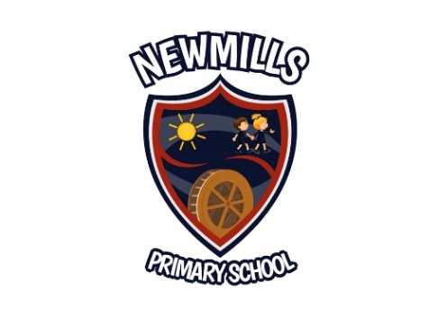

Dear Parents,
In the absence of our usual sports day, next week we are going to concentrate on keeping fit and active. We would like to see as many of our pupils as possible take part in the IFA, Footie's Fun Day. Event instructions and demonstration videos can be found on the IFA's website which include options for P1 – P4 and P5 –P7.
https://www.irishfa.com/irish-fa-foundation/grassroots-and-youth-football/footies-fun-day
Footie's Fun Day will run from 1st June - 5th June and we would like you to complete your activities during that time. You can enter all the activities or choose the ones you prefer. Those who take part will be entered into an IFA draw for a chance of winning;
- a football
- a t-shirt
- an at-home training pack
- a special mention on IFA online channels
The IFA has asked that parents share a photo or video on Twitter tagging the Irish FA Foundation: @IFAFootballDev, using the hashtag #FootiesFunDay.
To be entered into the draw I need to draw up list of those who have taken part. Please send me a photo / video to share on our school website and I will add your name to the list to send to our Let Them Play Officer. All photos / videos must be sent to me by 12 noon on Friday 5th June.
Please note, you do not have to enter the IFA draw. All pupils who send a photo completing any of the IFA activities will receive a prize from Newmills Primary School, so don’t forget to send your photo. Perhaps you were keeping fit and active in a different way. Why not let your school friends see how you have been keeping active and healthy?
We are looking forward to seeing how active our pupils have been.
Stay safe and take care,
Mrs Millar
smillar500@c2ken.net
ekeane630@c2ken.net
mjenkins152@c2ken.net
lyoung548@c2ken.net

